AUTOR: CRISTINA JIMENEZ JIMENEZ

1 - Dockefile allowing to test a Java SE app

FROM openjdk:8

WORKDIR /opt/app

COPY simple-app.jar /app.jar

CMD ["java", "-jar", "/app.jar"]

2 - Dockerfile allowinf to test an Angular app

# step 1: Compile and Build angular codebase

#Use official node image as the base image

FROM node:latest as build

#Set the working directory

WORKDIR /usr/local/app

#Add the source code to app

COPY . .

#Install all the dependencies

RUN npm install

#Generate the build of the application

RUN npm run build

#step 2: Serve app with nginx server

FROM nginx:latest

#copy the build output to replace the default nginx contents

COPY --from=build /usr/local/app/dist/docker-example/browser /usr/share/nginx/html

#Expose port 80

EXPOSE 80

DOCKER IMAGES FOR TWO EXERCISES:



DOCKER CONTAINER FOR TWO EXERCISES:



RUN EXERCISE1-CONTAINER:

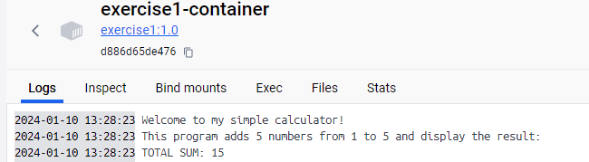

RUN CONTAINER-EXERCISE2

